ADDB assignment 1
<-- Question 1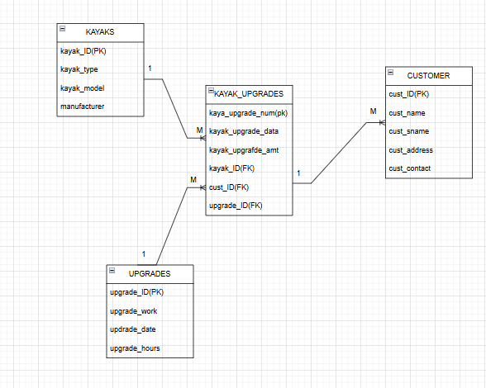

<--question 2
create database Earls_kayaking_store;
use database;

create table kayaks(
kayak_ID char(25) primary key,
kayak_type varchar(225),
kayak_model char(25),
manufacturer varchar(225));

insert into kayaks values('12345','single seater', 'K100' , 'feelfree');
insert into kayaks values('54321','tandem seater','J55','roamer');
insert into kayaks values('78945','fishing kayak','H9000','wavesport');
insert into kayaks values('98754','hobie kayak','A450','gemini');
insert into kayaks values('55311','canadian style','1920','surge');
select*from kayaks;

create table customers(
cust_ID char(25) primary key,
cust_name char(25),
cust_sname char(25),
cust_address varchar(255),
cust_contract varchar(255));

insert into customers values ('C115','jeff','Willis','3 main road','0821253659');
insert into customers values ('C116','Andre', 'Watson' '13 Cape Road', '0769658547');
insert into customers values ('C117', 'Wallis', 'Smith','3 mountain road','0863256574');
insert into customers values ('C118', 'alex','Hanson', '8 circle road','0762356587');
insert into customers values ('C119', 'Bob','Bitterhout' ,'15 main road', '0821235258');
insert into customers values ('C120', 'Thando','Zolani','88 summer road', '0847541254');
insert into customers values ('C121', 'philip', 'jackson','3 long road', '0745556658');
insert into customers values ('C122', 'Sarah', 'Jones','7sea road','0814745745');
select*from customers;

create table upgrades (
upgrade_ID char(25)primary key,
upgrade_work varchar(255),
upgrade_date varchar(255),
upgrade_hours varchar(255));

insert into upgrades values ('1', 'sonar device', '15 jul 22','5');
insert into upgrades values ('2', 'padded seats', '18 jul 22', '3');
insert into upgrades values ('3', 'GoPro camera mount', '19 jul 22','10');
select*from upgrades;

alter table kayaks add constraint pk_kayaks primary key (kayak_ID);

alter table customers add constraint pk_customers] primary key (cust_ID);

alter table upgrades add constraint pk_upgrades primary key (upgrade_ID);

delete from kayak_upgrades;
delete from kayaks;
delete from customers;
delete from upgrades;

create table kayak_upgrades (
kayak_upgrade_Num char(25) primary key,
kayak_upgrade_Date varchar(25),
kayak_upgrade_Amt decimal(10,2),
kayak_ID char(25),
cust_ID char(25),
upgrade_ID char(25),
foreign key (kayak_ID) references kayaks(kayak_ID),
foreign key (cust_ID) references customers(cust_ID),
foreign key (upgrade_ID)references upgrades(upgrade_ID));

insert into kayak_upgrades values ('101', '27 jul 19','75','98754', 'C121','3');
insert into kayak_upgrades values ('102', '20 jul 19' ,'30' ,'12345', 'C120', '2');
insert into kayak_upgrades values ('103', '23 jul 19', '75', '55311', 'C119' , '1');
insert into kayak_upgrades values ('104' , '17 jul 19' , '50', '54321', 'C117','1');
insert into kayak_upgrades values ('105', '19 jul 19' , '30', '12345' , 'C122' , '2');
select*from kayak_upgrades;

<--question 3.1
Create user: Tshepo_user;
create user C##Tshepo_user identified by tmphoabc2023;
grant create session to C##Tshepo_user;
grant select any table to C##Tshepo_user;

Create user: Mya_user;
create user C##Mya_user identified by mrobertabc2023;
grant create session to C##Mya_user;
grant insert any table to C##Mya;

<--question 4
create table sales (
kayak_ID char(25),
cust_ID char(25),
upgrade_ID char(25),
upgrade_amount decimal(10, 2));

select
s.kayak_ID,
s.cust_ID,
u.upgrade_hours,
(cast(u.upgrade_hours as int) * ku.upgrade_amount) as total_sales
from sales s
join upgrades u ON s.upgrade_ID = u.upgrade_ID
join kayak_upgrade ku ON u.upgrade_ID = ku.upgrade_ID;

<--qusetion 5
select
c.cust_name || ' ' || c.cust_sname AS full_name,
k.kayak_type,
u.upgrade_hours,
u.upgrade_work,
ku.kayak_upgrade_Amt
from kayak_upgrades ku
join customers c on ku.cust_ID = c.cust_ID
join kayaks k on ku.kayak_ID = k.kayak_ID
join upgrades u on ku.upgrade_ID = u.upgrade_ID;
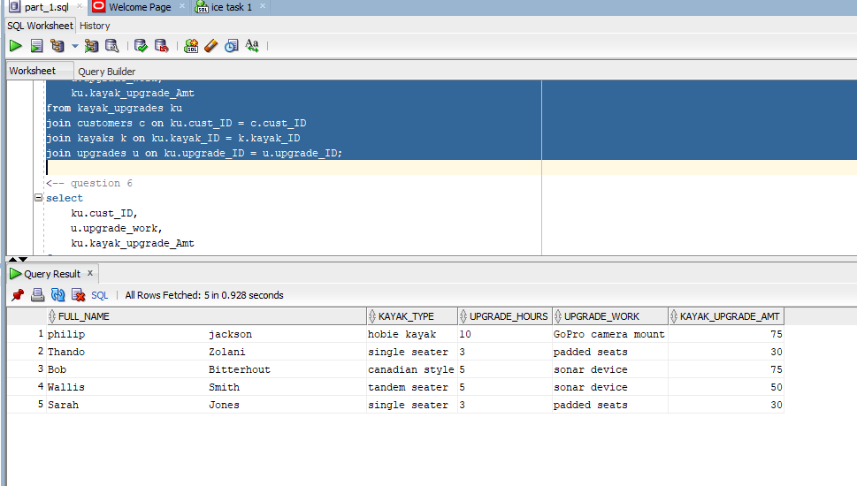

<-- question 6
select
ku.cust_ID,
u.upgrade_work,
ku.kayak_upgrade_Amt
from
kayak_upgrades ku
join
upgrades u ON ku.upgrade_ID = u.upgrade_ID
where
ku.kayak_upgrade_Amt > 50;
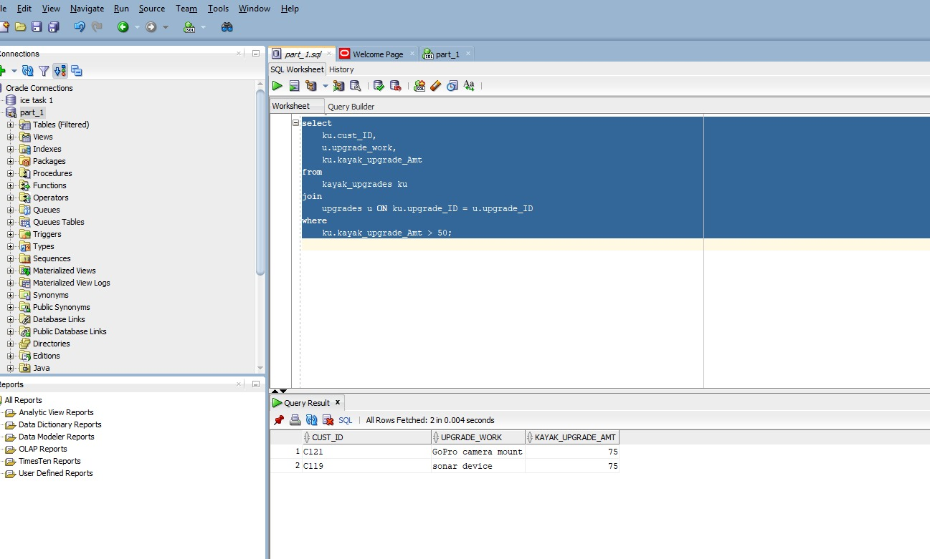

<--question 7
select
c.cust_name,
c.cust_sname,
k.kayak_type,
u.upgrade_work,
u.upgrade_date,
ku.kayak_upgrade_Amt AS upgrade_amount,
ku.kayak_upgrade_Amt * 0.10 AS discount_amount,
(ku.kayak_upgrade_Amt - (ku.kayak_upgrade_Amt * 0.10)) AS final_amount
from
kayak_upgrades ku
join
customers c ON ku.cust_ID = c.cust_ID
join
kayaks k ON ku.kayak_ID = k.kayak_ID
join
upgrades u ON ku.upgrade_ID = u.upgrade_ID
where
c.cust_ID = 'C121';
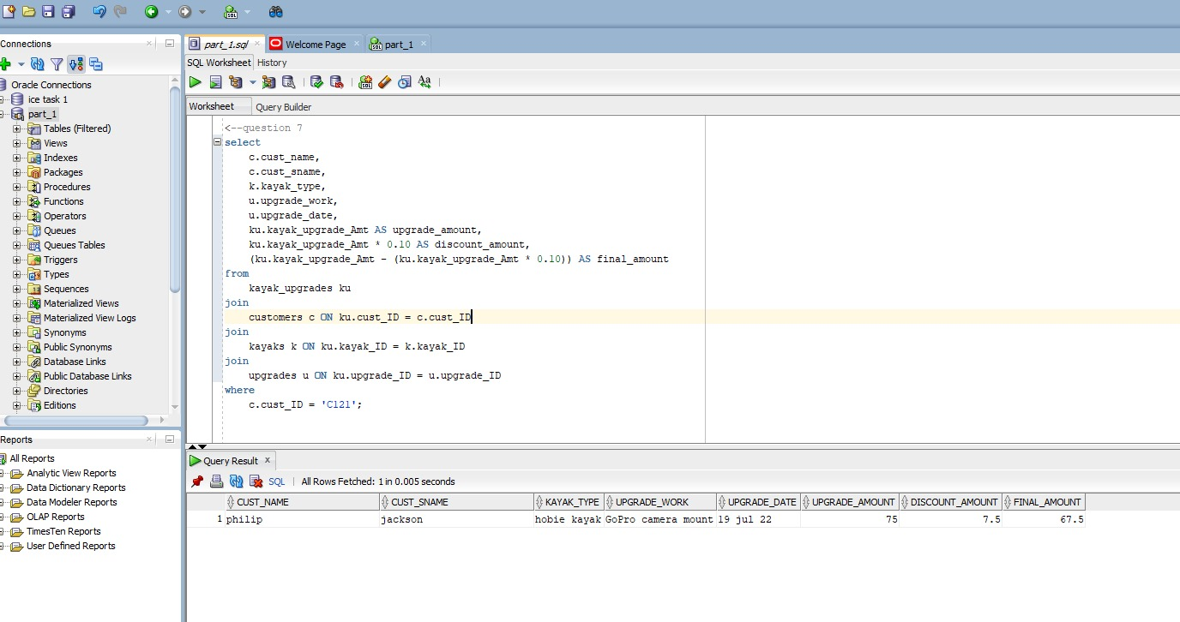

<--question 8
create view vwCustUpgrade as
select
c.cust_name || ' ' || c.cust_sname as customer_full_name,
k.kayak_type,
u.upgrade_work,
c.cust_contract
from
kayak_upgrades ku
join
customers c on ku.cust_ID = c.cust_ID
join
kayaks k on ku.kayak_ID = k.kayak_ID
join
upgrades u on ku.upgrade_ID = u.upgrade_ID
where
c.cust_address like '%summer%';
select*from vwCustUpgrade;
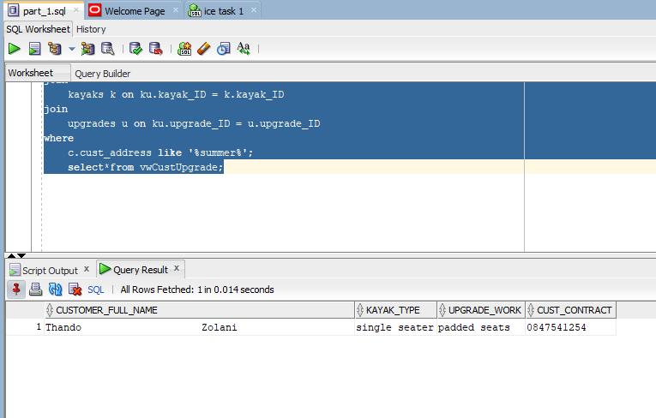
<-- Question 3.2
<-- separation of duties is important because it prevents fraud and misuse and improves accountability

